NAME:- Talari Vyshnavi
USER ID:- 34725
BATCH ID:- 25VID2550
EMAIL ID:- talari.vyshu@gmail.com

ASSIGNMENT
TOPICS:-
- Process check and Delete
- Loop based scipting operations
- Set-Ini Value
- Toolkit Logging location and how its configured
- MSI/MSP Logging
- Individual Command logging within Script How to catch return Codes with in PowerShell.
- MSIX Technology Fundamentals with Architecture

- PROCESS CHECK AND DELETE:-
PSAppDeployToolkit, you can check and delete processes using a combination of functions. To check for processes, you can use the Get-Process cmdlet, which returns process objects. To delete processes, you can use the Stop-Process cmdlet, specifying the process name or ID.
Get-Process : Use this cmdlet to retrieve process objects.

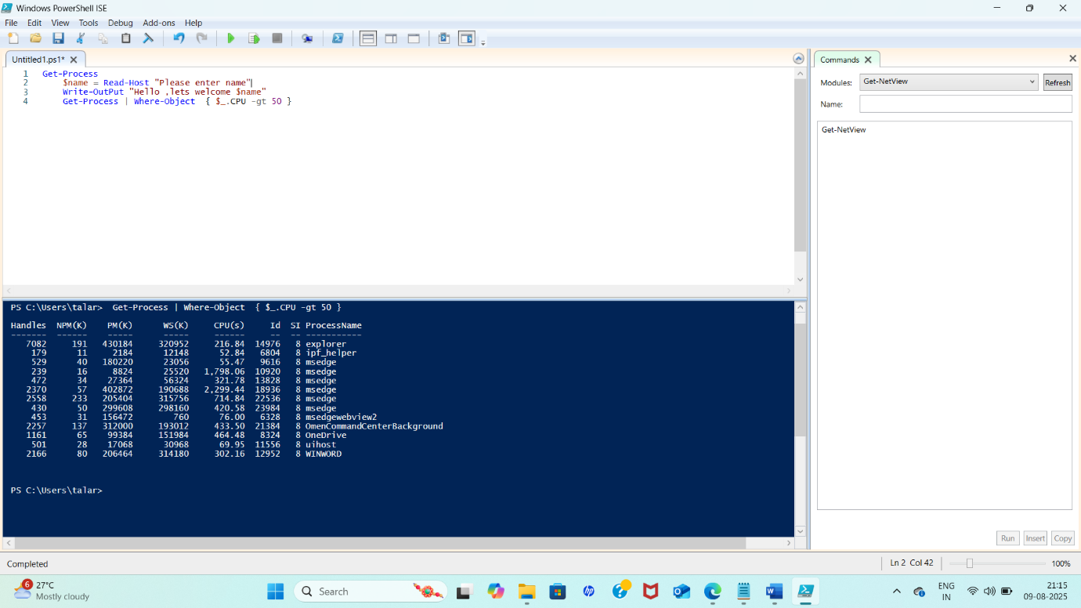

Checking for a specific process : you can use the-Name parameter with Get-Process is running. If it returns any output, the process is running. If no output is returned, the process is not running.
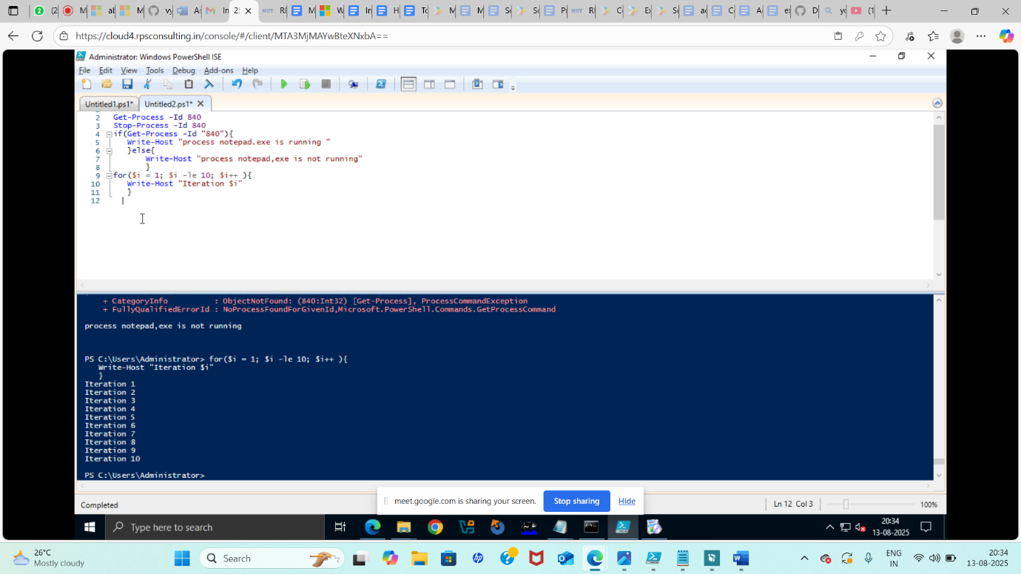

- Loop based scripting operations :-
Loop based scripting operations just means running a block of code repeatedly until a condition is met, or for a certain numder of times.
Example:-

For($i = 1; $i -le 10; $i++)
{
Write-Host “Iteration $i”
}
This an example code for iteration.
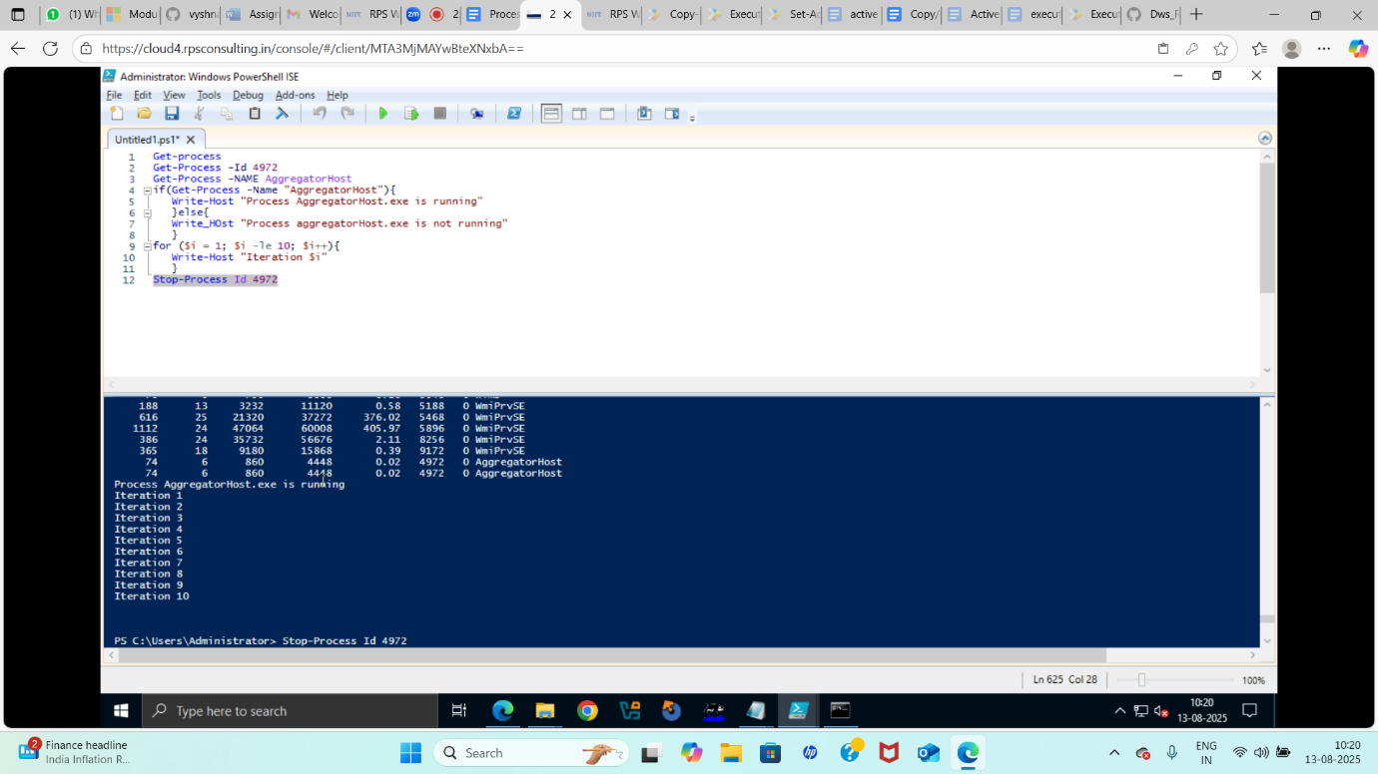

- Set-Ini Value :-
There is no built-in Set-IniValue cmdlet -but many packaging frameworks (like PsAppdeployToolkit) include one.
Syntax:-
Set-IniValue -FilePath “c:\Path\config,ini” -Selection “settings” -Key “Username” -Value “vyshnavi”
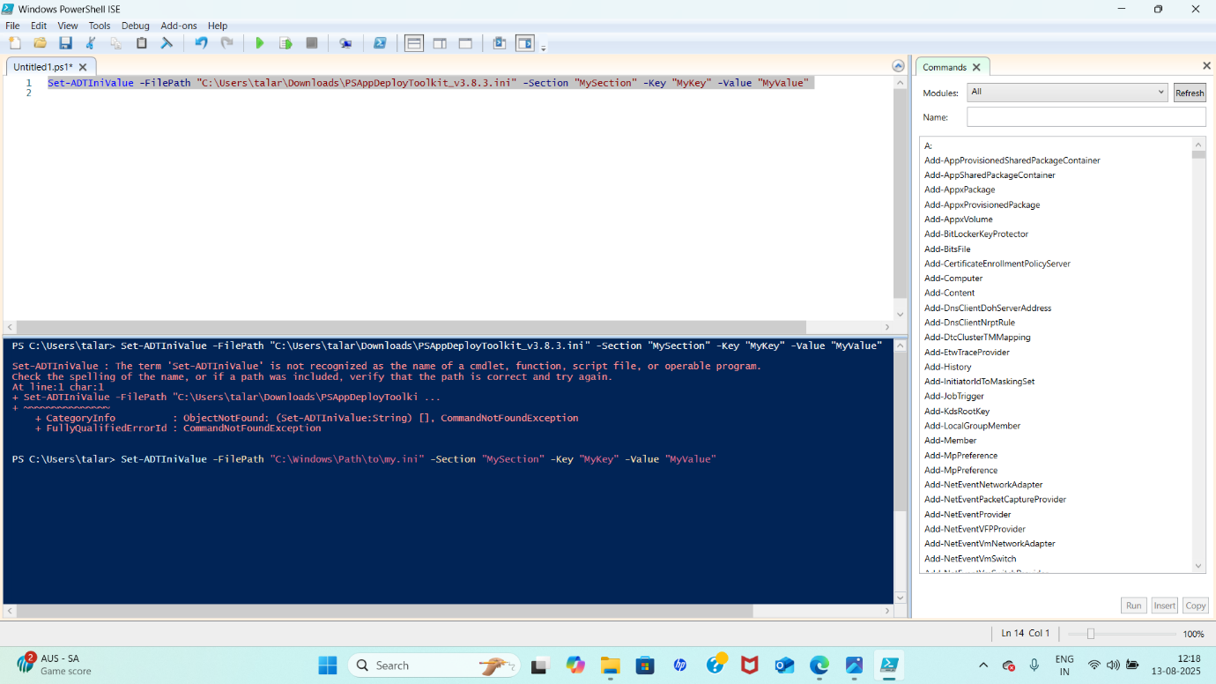

  - Toolkit Logging location and how its configured :-
PSADT, Logging is built-in so every action your script takes is recorded in a structured log file.
Why this location?
- Centralized in c:\Windows\Logs\Software for easy collection.
- Accessible without user permissions issues.
- Consistent for all deployments.
Example:-$ToolKit_LogDir = “D:\CustomLogs”
$ToolKit_LogName = “MyAppInstall_{ComputreName}_${DateTime} .log”
Initilalize-Logging
- Individual Command logging within Script :-
You don’t have to manually write logs for every step, because the toolkit already provides logging functions that automatically write to the active log file.
Individual commands are;
Write-Log : Logs a custom messages tonthe toolkit log.
Write-Host : Only shows in console – avoid for logging.
Write-Verbose : Writes verbose info
Write-Error : Logs an error message
Write-Warning : Logs a warning message
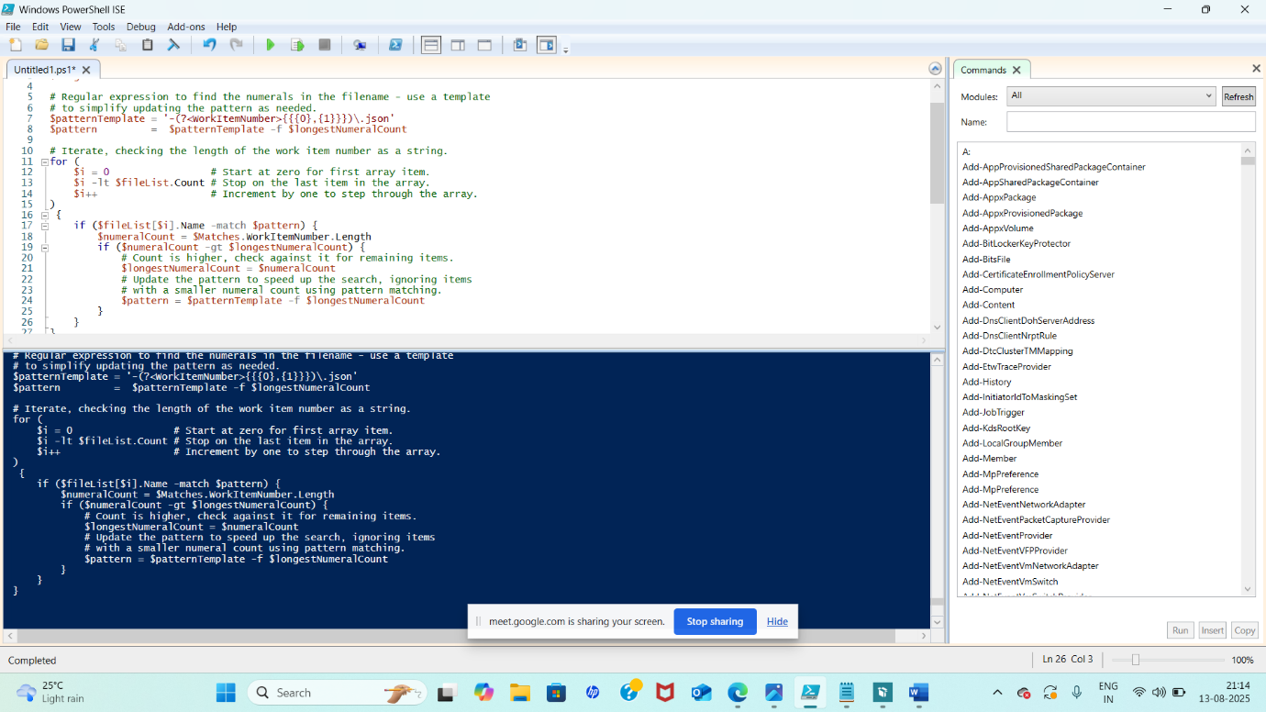

- MSI/MSP Logging :-
Logging for MSI and MSP installations is handled automatically by the toolkit’s Execute-MSI function, but you can also control it manually.
MSI :-
Execute-MSI -Action Install -Path “MyApp.msi”
MSP :-
Execute-MSI -Action Patch -Path “MyPatch.msp”

Customizing MSI/MSP logging:-
- Log file name
- Log location
- MSI logging switches
Example-
Execute-MSI -Action Install -Path “MyApp.msi” -Parameters ‘/QN’ -MsiLoggingParameters ‘/L*D “D:\CustomLogs\MyApp_MSI.log” ’

- MSIX Technology Fundamentals with Architecture :-
MSIX is Microsoft’s modern packaging format for windows apps.
It combines the best parts of :
- MSI: structured installation/uninstallation
- AppX: security, isolation, and stroe compatibility
- ClickOnce/App-V: streaming, versioning, and containerization

MSIX Packaging tool:-

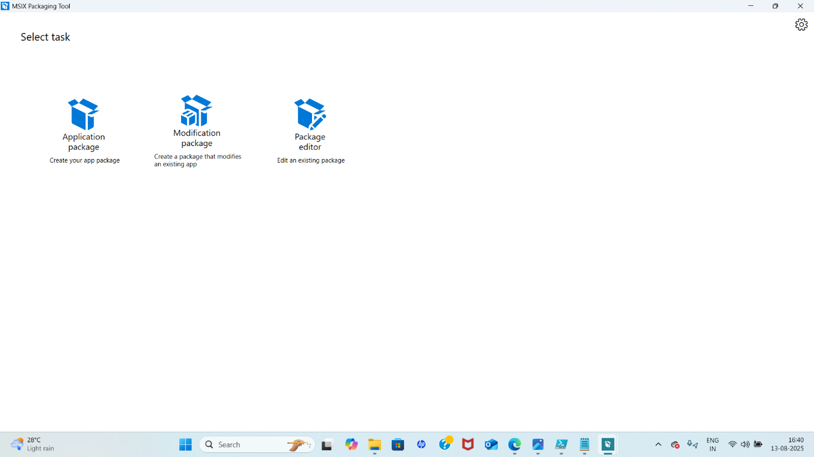

MSIX ARCHITECTURE
─────────────────────┐
│ Developer / IT Pro │
└──────────┬──────────┘
│
┌──────────▼──────────┐
│ MSIX Package │
│ (App Files + AppxMan│
│ ifest + Signature) │
└──────────┬──────────┘
│
┌───────────▼───────────┐
│ MSIX Packaging Format │
└───────────┬───────────┘
│
┌──────────▼──────────┐
│ Deployment Stack │
│ (OS APIs, MSIX Core)│
└──────────┬──────────┘
│
┌───────────────▼────────────────┐
│ MSIX Runtime Environment │
│ - App Container │
│ - File System Virtualization │
│ - Registry Virtualization │
│ - Package Identity │
└───────────────┬────────────────┘
│
┌────────▼────────┐
│ Running App │
└─────────────────┘

